Accessing Minikube node via SSH, creating a directory /mnt/data, and adding a test file (index.html) to verify Kubernetes storage path.

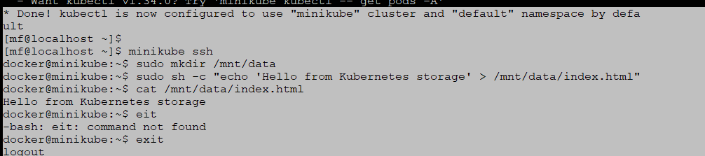

Creating a PersistentVolume (PV) in Kubernetes and verifying it with kubectl get pv

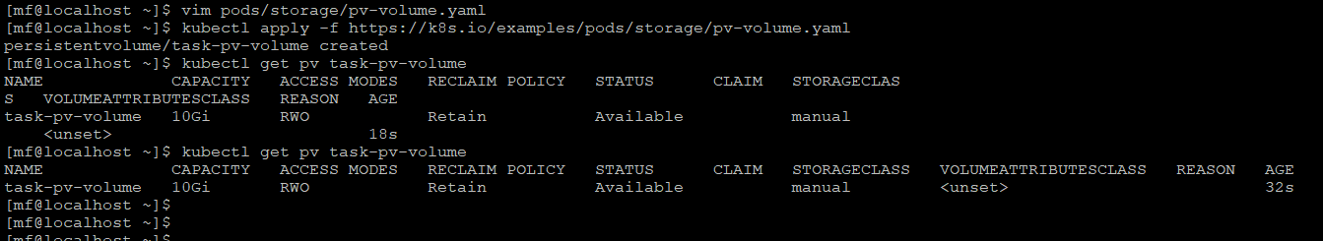

Creating a PersistentVolumeClaim (PVC) in Kubernetes and verifying that the PersistentVolume (PV) is successfully bound to it.

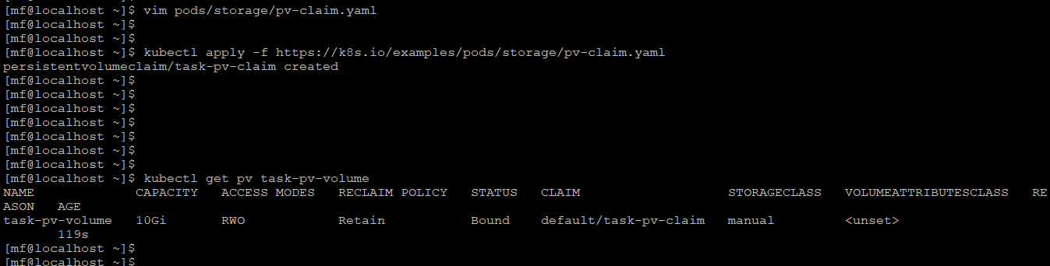

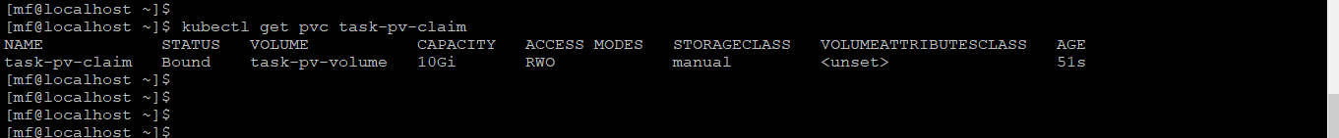

Deploying a Pod in Kubernetes that uses the PersistentVolumeClaim (PVC) and verifying that the Pod is running successfully.

